2018年普通高等学校招生全国统一考试(江苏卷)
第一部分 听力（共两节，满分20分）
第一节（共5小题；每小题1分，满分5分）
听下面5段对话。每段对话后有一个小题，从题中所给的A、B、C三个选项中选出最佳选项。听完每段对话后，你都有10秒钟的时间来回答有关小题和阅读下一小题。每段对话仅读一遍。
1．What will James do tomorrow?
A．Watch a TV program.
B．Give a talk.
C．Write a report.
2．What can we say about the woman?
A．She’s generous.
B．She’s curious.
C．She’s helpful.
3．When does the train leave?
A．At 6：30.
B．At 8：30.
C．At 10：30.
4．How does the woman go to work?
A．By car.
B．On foot.
C．By bike.
5．What is the probable relationship between the speakers?
A．Classmates.
B．Teacher and student.
C．Doctor and patient.
第二节（共15小题；每小题1分，满分15分）
听下面5段对话或独白。每段对话或独白后有几个小题，从题中所给的A、B、C三个选项中选出最佳选项。听每段对话或独白前，你将有时间阅读各个小题，每小题5秒钟；听完后，各小题将给出5秒钟的作答时间。每段对话或独白读两遍。
听第6段材料，回答第6、7题。
6．What does the woman regret?
A．Giving up her research.
B．Dropping out of college.
C．Changing her major.
7．What is the woman interested in studying now?
A．Ecology.
B．Education.
C．Chemistry.
听第7段材料，回答第8、9题。
8．What is the man?
A．A hotel manager.
B．A tour guide.
C．A taxi driver.
9．What is the man doing for the woman?
A．Looking for some local foods.
B．Showing her around the seaside.
C．Offering information about a hotel.
听第8段材料，回答第10至12题。
10．Where does the conversation probably take place?
A．In an office.
B．At home.
C．At a restaurant.
11．What will the speakers do tomorrow evening?
A．Go to a concert.
B．Visit a friend.
C．Work extra hours.
12．Who is Alice going to call?
A．Mike.
B．Joan.
C．Catherine.
听第9段材料，回答第13至16题。
13．Why does the woman meet the man?
A．To look at an apartment.
B．To deliver some furniture.
C．To have a meal together.
14．What does the woman like about the carpet?
A．Its color.
B．Its design.
C．Its quality.
15．What does the man say about the kitchen?
A．It’s a good size.
B．It’s newly painted.
C．It’s adequately equipped.
16．What will the woman probably do next?
A．Go downtown.
B．Talk with her friend.
C．Make payment.
听第10段材料，回答第17至20题。
17．Who is the speaker probably talking to?
A．Movie fans.
B．News reporters.
C．College students.
18．When did the speaker take English classes?
A．Before he left his hometown.
B．After he came to America.
C．When he was 15 years old.
19．How does the speaker feel about his teacher?
A．He’s proud.
B．He’s sympathetic.
C．He’s grateful.
20．What does the speaker mainly talk about?
A．How education shaped his life.
B．How his language skills improved.
C．How he managed his business well.
答案 1.B 2.C 3.C 4.B 5.A 6.B 7.A 8.B 9．C 10.C 11.A 12.B 13.A
14.A 15.C 16.B 17．C 18.B 19.C 20.A
听力原文
Text 1
W：James，you’ve been watching TV for the whole evening.What’s on?
M：It’s a science program on the origin of the universe.I’ll give a presentation on it in my class tomorrow.
Text 2
M：Hello! Do you have The Best of Mozart?
W：Er...sorry.We’ve just sold out.But we can order one for you.If you give us your number，we’ll call you when the CD arrives.
Text 3
W：We’d better be going now.Or we’ll be late for the train.
M：No rush.It’s 8：30 now.We still have two hours.
Text 4
M：I am so tired of trying all those hours to work.
W：Yeah，I know what you mean.I used to drive two hours to work each day.But now I live within walking distance of my office.I don’t even need a bike.
Text 5
W：Hi，Andy.I didn’t see you in Professor Smith’s class yesterday.What happened?
M：Well，I had a headache，so I called him and asked for sick leave.
Text 6
W：The biggest mistake I made...eh...was leaving college in my last year and not completing my education.So I’m thinking of going back to school.
M：School？To study what?
W：Ecology.I’m interested in the relationship between humans and nature.
M：Cool! Is it what you studied years ago?
W：No，I majored in chemistry then.
Text 7
M：Good morning，madam.I’m your guide for this trip.
W：How lovely! Could you tell me about the hotel I’m going to stay at?
M：Yes，of course! The Grand Hotel opened in 1990，and it sits on the seaside along the South Coast Highway.It’s the most beautiful hotel here.
W：That sounds great!
M：And there are some restaurants outside.So at dinner time，you’d have a lot of choices.
W：That’s really nice.I like to have some local foods while traveling.What about the scenery around it?
M：The hotel has the best views of the Pacific Ocean.
W：Oh，I think I will love this hotel.
Text 8
W：Hi，Mike.
M：Hi，Alice.Nice to see you.You don’t often come here.
W：I usually have fast food delivered to my office.I just come here for a change today.
M：The environment here is good，clean and relatively quiet.
W：Yeah.And I heard the food is tasty.By the way，are you going to the concert tomorrow evening?
M：Yes，are you?
W：Yeah! Catherine was supposed to go with me，but she may have to work extra hours tomorrow.Do you know anyone who might like to go?
M：No，but if you like，I can ask around.Eh...Joan might want to go.
W：Oh，yes，she is a great fan of classical music.I’ll give her a ring after lunch.
Text 9
W：Hi.I’ve only just arrived.
M：Oh，good.Now，here are the keys.Let’s go in.There are two apartments.The one for rent is on the right.Do come in.
W：Thank you.I like the carpet.The color is nice，isn’t it?
M：Yes，and this apartment is in good condition.Here is your lounge.
W：Where would we eat?
M：There is this corner here，or you can use your kitchen.Come and see.
W：The kitchen is quite small.
M：Yeah，but it has everything—cooker，fridge，even a dishwasher.
W：And there are lots of cupboards.
M：Let me show you the bedrooms.This is the smaller one.
W：It’s a good size，though.
M：Now come into the other bedroom.You can see the bathroom，too.
W：Yes，it is very nice.But I’ll have to ask my friend first and we will come together.I understand it’s $ 800 a month.
M：Yes，but a few blocks downtown would be much more expensive.
W：Well，thank you.I will be in touch.
Text 10
M：Thank you very much.Thank you，Doctor Johnson.Well，it is really great to be back at university again.The thing that I wanted to tell you today is this：Education is important.When I came to the US，I was only thinking about being a carpenter，but I could not read the newspaper.And I could not understand the news on television or movies or anything like this.So I entered the city college to take English classes for foreign students.I was very proud that I was going to a college because no one in my family ever went to any college or to any university.You know，when you’re fifteen years old in my country，you finish school and then you learn a trade.And that’s exactly what I did.When I was fifteen years old，I learned how to be a carpenter.A year later，I came to America.Luckily，I met a very good teacher who encouraged me to take some math classes，business classes and history classes.And I became a fulltime college student.And today when I look back，I’m so happy because you never know where life will take you.All of a sudden，I started making money because I was really good at math.You know，how to work out everything with math is so important.This is something that I learned when I started my own business，which is doing really well.
第二部分：英语知识运用(共两节，满分35分)
第一节：单项填空(共15小题；每小题1分，满分15分)
请认真阅读下面各题，从题中所给的A、B、C、D四个选项中，选出最佳选项，并在答题卡上将该项涂黑。
例：It is generally considered unwise to give a child he or she wants.
A．however B．whatever
C．whichever D．whenever
答案 B
21．By boat is the only way to get here，which is we arrived.
A．where B．when
C．why D．how
答案 D
解析 句意为：坐船是到达这里的唯一方法，这就是我们如何(how)到达的。where表地点；when表时间；why表原因；how表方式。
22．Kids shouldn’t have access to violent films because they might the things they see.
A．indicate B．investigate
C．imitate D．innovate
答案 C
解析 句意为：孩子们不应该有机会接触暴力电影，因为他们可能会模仿(imitate)他们看到的东西。C项imitate“模仿”符合语境。indicate表明，暗示；investigate调查；innovate创新，改革。
23．Selfdriving is an area China and the rest of the world are on the same starting line.
A．that B．where
C．which D．when
答案 B
解析 句意为：自动驾驶是一个中国和世界上其他国家处在同一起跑线的领域。分析句子结构可知，area作定语从句的先行词，从句中缺少地点状语，要用where引导。that和which为关系代词，在定语从句中作主语、宾语或表语；when是关系副词，在定语从句中作时间状语。
24．It’s strange that he have taken the books without the owner’s permission.
A．would B．should
C．could D．might
答案 B
解析 句意为：很奇怪，他竟然未经主人同意就拿走了那些书。此处should作情态动词，表示“竟然”，符合句意，故选B。
25．Developing the Yangtze River Economic Belt is a systematic project which a clear road map and timetable.
A．calls for B．calls on
C．calls off D．calls up
答案 A
解析 句意为：发展长江经济带是一个系统化项目，该项目要求(call for)有清晰的路线图和时间表。call for要求，需要；call on拜访，号召；call off取消；call up打电话。
26．Around 13,500 new jobs were created during the period， the expected number of 12,000 held by market analysts.
A．having exceeded B．to exceed
C．exceeded D．exceeding
答案 D
解析 句意为：在这段时期创造了大约13 500个新工作，超过了市场分析师认为的12 000个的预期数量。were created是谓语，因此exceed只能用非谓语动词形式作伴随状语。A项having exceeded表示exceed的动作发生在were created之前，不符合语境；B项to exceed不能作伴随状语；C项exceeded表示主语与exceed之间为被动关系，也不符合语境。故选D。
27．There is a good social life in the village，and I wish I a second chance to become more involved.
A．had B．will have
C．would have had D．have had
答案 A
解析 句意为：在这个村子里社交生活良好，我希望我能再有机会更多地参与其中。I wish后接从句，从句要用虚拟语气。叙述与现在事实相反的假设，从句谓语用did(be动词用were)；叙述与过去事实相反的假设，从句谓语用had done；叙述与将来事实相反的假设，从句谓语用would/could do。由语境可知，此处叙述与现在事实相反的假设，故选A。
28．—You know what？I’ve got a New Year concert ticket.
—Oh， You’re kidding.
A．so what? B．go ahead.
C．come on. D．what for?
答案 C
解析 句意为：——你猜怎么着？我有一张新年音乐会的票。——噢，得了吧。你在开玩笑吧。so what意为“那又怎么样呢”，表示对对方说的话不以为然；go ahead意为“去吧，干吧”，用于鼓励别人；come on可意为“加油”，用于激励别人，也可意为“得了吧，怎么会呢”，表示不相信；what for用于询问目的，意为“为了什么”。由语境可知C项正确。
29． you can sleep well，you will lose the ability to focus，plan and stay motivated after one or two nights.
A．Once B．Unless
C．If D．When
答案 B
解析 句意为：你如果睡不好的话，一两个晚上后就会失去集中注意力、做好规划和保持积极性的能力。B项unless意为“如果不，除非”，引导条件状语从句，符合语境。once一旦；if如果；when当……的时候。
30．I was sent to the village last month to see how the development plan in the past two years.
A．had been carried out
B．would be carried out
C．is being carried out
D．has been carried out
答案 A
解析 句意为：上个月我被派到那个村子里去看了看在过去的两年里这个发展计划实施得怎么样了。根据in the past two years可知应用完成时，先排除B、C两项；再根据carry out发生在was sent之前可知，应用过去完成时的被动语态，故选A。
31．Hopefully in 2025 we will no longer be emailing each other，for we more convenient electronic communication tools by then.
A．have developed
B．had developed
C．will have developed
D．developed
答案 C
解析 句意为：在2025年我们有望不用再互相发电子邮件了，因为到那时我们将已经研制出更便捷的电子交流工具了。根据句中的in 2025以及by then可知，后面应用将来完成时will have done，故选C项。
32．Try to understand what’s actually happening instead of acting on the you’ve made.
A．assignment B．association
C．acquisition D．assumption
答案 D
解析 句意为：努力弄明白实际正在发生的事情，而不是按照你做出的假设去行动。D项assumption意为“假设”，符合语境。you’ve made是定语从句，修饰assumption，make an assumption意为“做出假设”。assignment任务，作业；association联系；acquisition获得，得到。
33．China’s soft power grows the increasing appreciation and understanding of China globally.
A．in line with B．in reply to
C．in return for D．in honour of
答案 A
解析 句意为：中国的软实力在增长，这与中国在全球范围内得到越来越多的欣赏和理解是一致的。A项in line with意为“与……一致”，符合语境。in reply to回复，答复；in return for作为对……的回报；in honour of为了向……表示尊敬。
34．Despite the poor service of the hotel，the manager is to invest in sufficient training for his staff.
A．keen B．reluctant
C．anxious D．ready
答案 B
解析 句意为：虽然宾馆的服务很差，但经理仍然不愿意投资对员工进行充分的培训。B项reluctant意为“不情愿的”，符合语境。keen渴望的，着迷的；anxious担心的，焦虑的；ready准备好的，愿意的。
35．—What happened？Your boss seems to .
—Didn’t you know his secretary leaked the secret report to the press?
A．be over the moon
B．laugh his head off
C．be all ears
D．fly off the handle
答案 D
解析 句意为：——发生了什么事？你的老板似乎 。——难道你不知道他的秘书把这个秘密报告泄露给了新闻记者了吗？D项fly off the handle意为“大发雷霆”，符合语境。be over the moon欣喜若狂；laugh his head off大笑不止，狂笑不已；be all ears全神贯注地听，洗耳恭听。
第二节：完形填空(共20小题；每小题1分，满分20分)
请认真阅读下面短文，从短文后各题所给的A、B、C、D四个选项中，选出最佳选项，并在答题卡上将该项涂黑。
Raynor Winn and her husband Moth became homeless due to their wrong investment.Their savings had been 36 to pay lawyers’ fees.To make matters worse，Moth was diagnosed(诊断) with a 37 disease.There was no 38 ，only pain relief.
Failing to find any other way out，they decided to make a 39 journey，as they caught sight of an old hikers’(徒步旅行者) guide.
This was a long journey of unaccustomed hardship and 40 recovery.When leaving home，Raynor and Moth had just ￡320 in the bank.They planned to keep the 41 low by living on boiled noodles，with the 42 hamburger shop treat.
Wild camping is 43 in England.To avoid being caught，the Winns had to get their tent up 44 and packed it away early in the morning.The Winns soon discovered that daily hiking in their 50s is a lot 45 than they remember it was in their 20s.Raynor 46 all over and desired a bath.Moth，meanwhile，after an initial 47 ，found his symptoms were strangely 48 by their daily tiring journey.
49 ，the couple found that their bodies turned for the better，with refound strong muscles that they thought had 50 forever.“Our hair was fried and falling out，nails broken，clothes 51 to a thread，but we were alive.”
During the journey，Raynor began a career as a nature writer.She writes，“ 52 had taken every material thing from me and left me torn bare，an empty page at the end of a(n) 53 written book.It had also given me a 54 ，either to leave that page 55 or to keep writing the story with hope.I chose hope.”

36．A.drawn up B．used up
C．backed up D．kept up
答案 B
解析 文章开头交代，夫妻俩因投资不当而变得无家可归。由此可推知，为了支付律师费，他们的积蓄被用完(use up)了。draw up起草，(车辆)停下；back up支持；keep up保持，继续。
37．A.mild B．common
C．preventable D．serious
答案 D
解析 由空前的“to make matters worse”(更糟糕的是)及后文的提示“only pain relief”可知Moth被诊断出得了重(serious)病。mild温和的，轻微的；common常见的；preventable可预防的。
38．A.cure B．luck
C．care D．promise
答案 A
解析 由空后的“only pain relief”可知，此处是说该病无法治愈(cure)。luck运气，好运；care关怀，照料；promise许诺，答应。
39．A.business B．walking
C．bus D．rail
答案 B
解析 由空后的hikers可知是徒步旅行，故选walking。business商业；bus公共汽车；rail铁路。
40．A.expected B．frightening
C．disappointing D．surprising
答案 D
解析 由下文可知这次徒步旅行收到了惊人的(surprising)康复效果。expected预期的；frightening吓人的；disappointing令人失望的。
41．A.budget B．revenue
C．compensation D．allowance
答案 A
解析 空前提到，他们只有320英镑，空后提到他们以煮面条为食，由此可知他们计划保持低预算(budget)。revenue税收，收益；compensation补偿费，赔偿金；allowance津贴，零用钱。
42．A.frequent B．occasional
C．abundant D．constant
答案 B
解析 因为预算低，他们只能靠煮面条过活，偶尔(occasional)去汉堡店款待一下自己。空后的treat是名词，有“款待”之意。因为预算低，所以去汉堡店不可能是frequent“频繁的”、abundant“充足的”或constant“经常的”。
43．A.unpopular B．lawful
C．attractive D．illegal
答案 D
解析 由下文的“To avoid being caught”(避免被抓)可知，在英国，野外宿营是非法的(illegal)。unpopular不流行的；lawful合法的；attractive吸引人的。
44．A.soon B．early
C．late D．slowly
答案 C
解析 为了避免被抓，他们只好很晚(late)才撑起帐篷并且一早就把帐篷收起来。显然，该空与early相对，只能选late。soon快，不久；early早；slowly缓慢地。
45．A.harder B．easier
C．cheaper D．funnier
答案 A
解析 根据常识及下文的Raynor浑身疼痛可知夫妻俩很快发现，他们在50多岁时的徒步旅行比记忆中20多岁时的徒步旅行艰难多了(harder)。easier更容易的；cheaper更便宜的；funnier更有趣的。
46．A.rolled B．bled
C．ached D．trembled
答案 C
解析 通读上下文可知，夫妻俩都50多岁了，每天徒步旅行，Raynor浑身疼痛(ache all over)，想洗个澡。roll滚动；bleed流血；tremble颤抖。
47．A.struggle B．progress
C．excitement D．research
答案 A
解析 上文提到Moth得了重病，所以旅行开始时他一定是痛苦的，故选struggle“挣扎”。progress进步；excitement兴奋；research研究，调查。
48．A.developed B．controlled
C．reduced D．increased
答案 C
解析 由空前的strangely(奇怪地)及下一段中的“their bodies turned for the better”(他们的身体好转了)可知Moth的症状减轻(reduce)了。develop发展，成长；control控制；increase增加。
49．A.Initially B．Eventually
C．Temporarily D．Consequently
答案 B
解析 最后(eventually)，夫妻俩发现他们的身体都有所好转。initially最初；temporarily临时地；consequently因此，所以。
50．A.gained B．kept
C．wounded D．lost
答案 D
解析 夫妻俩身体好转，发现本以为永远消失(lose)了的强壮肌肉重新出现了。gain获得；keep保持；wound使受伤。
51．A.sewn B．washed
C．worn D．ironed
答案 C
解析 由空前描述的“头发干枯脱落，指甲断裂”可知该空是说衣服被磨损(wear)成线。sew缝；wash洗；iron熨。
52．A.Doctors B．Hiking
C．Lawyers D．Homelessness
答案 D
解析 通读上下文可知，把她所有物质的东西都带走的不可能是“医生”“徒步旅行”或“律师”，而应是无家可归(homelessness)。
53．A.well B．partly
C．neatly D．originally
答案 B
解析 句意为：无家可归带走了我所有物质的东西，我被撕得支离破碎，在人生这本已经写完一部分的书的最后留下空白的一页。Raynor把自己目前的人生比作已经写完一部分的书(partly written book)。well written写得好；neatly written写得整洁；originally written原创的。
54．A.choice B．reward
C．promise D．break
答案 A
解析 由空后的either...or...及最后一句“I chose hope.(我选择了希望)”可知该处意为“它也给了我一个选择(choice)”。reward奖赏，报酬；promise承诺；break间歇。
55．A.loose B．full
C．blank D．missing
答案 C
解析 上文的“an empty page”提示该空填blank(空白的)。给Raynor的选择是“或者留着那页空白或者带着希望继续写故事”。loose松的；full满的；missing丢失的。
第三部分：阅读理解(共15小题；每小题2分，满分30分)
请认真阅读下列短文，从短文后各题所给的A、B、C、D 四个选项中，选出最佳选项，并在答题卡上将该项涂黑。
A
INCLUDEPICTURE "\\\\张潇\\f\\幻灯片原文件\\2018\\同步\\英语\\2018英语高考题\\S0.TIF" \* MERGEFORMATINET INCLUDEPICTURE "\\\\张潇\\f\\幻灯片原文件\\2018\\同步\\英语\\2018英语高考题\\S0.TIF" \* MERGEFORMATINET INCLUDEPICTURE "\\\\张潇\\f\\幻灯片原文件\\2018\\同步\\英语\\2018英语高考题\\S0.TIF" \* MERGEFORMATINET 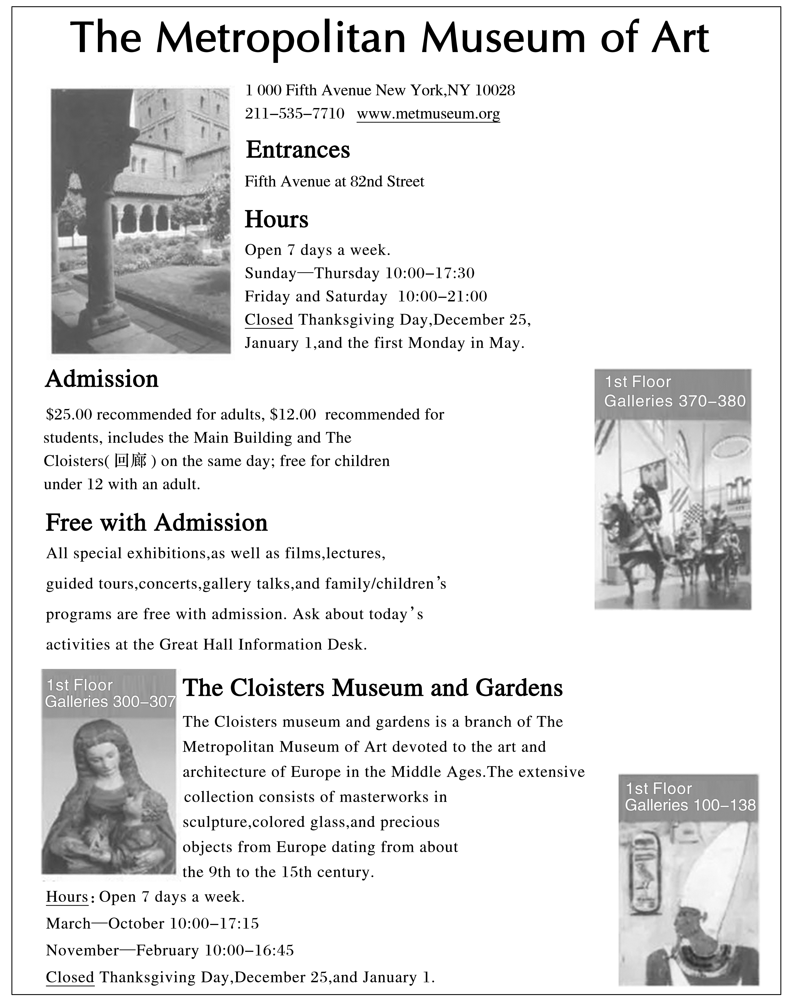

56．How much may they pay if an 11yearold girl and her working parents visit the museum?
A. INCLUDEPICTURE "\\\\张潇\\f\\幻灯片原文件\\2018\\同步\\英语\\2018英语高考题\\美元.TIF" \* MERGEFORMATINET INCLUDEPICTURE "\\\\张潇\\f\\幻灯片原文件\\2018\\同步\\英语\\2018英语高考题\\美元.TIF" \* MERGEFORMATINET INCLUDEPICTURE "\\\\张潇\\f\\幻灯片原文件\\2018\\同步\\英语\\2018英语高考题\\美元.TIF" \* MERGEFORMATINET 12. B. INCLUDEPICTURE "\\\\张潇\\f\\幻灯片原文件\\2018\\同步\\英语\\2018英语高考题\\美元.TIF" \* MERGEFORMATINET INCLUDEPICTURE "\\\\张潇\\f\\幻灯片原文件\\2018\\同步\\英语\\2018英语高考题\\美元.TIF" \* MERGEFORMATINET INCLUDEPICTURE "\\\\张潇\\f\\幻灯片原文件\\2018\\同步\\英语\\2018英语高考题\\美元.TIF" \* MERGEFORMATINET 37.
C. INCLUDEPICTURE "\\\\张潇\\f\\幻灯片原文件\\2018\\同步\\英语\\2018英语高考题\\美元.TIF" \* MERGEFORMATINET INCLUDEPICTURE "\\\\张潇\\f\\幻灯片原文件\\2018\\同步\\英语\\2018英语高考题\\美元.TIF" \* MERGEFORMATINET INCLUDEPICTURE "\\\\张潇\\f\\幻灯片原文件\\2018\\同步\\英语\\2018英语高考题\\美元.TIF" \* MERGEFORMATINET 50. D. INCLUDEPICTURE "\\\\张潇\\f\\幻灯片原文件\\2018\\同步\\英语\\2018英语高考题\\美元.TIF" \* MERGEFORMATINET INCLUDEPICTURE "\\\\张潇\\f\\幻灯片原文件\\2018\\同步\\英语\\2018英语高考题\\美元.TIF" \* MERGEFORMATINET INCLUDEPICTURE "\\\\张潇\\f\\幻灯片原文件\\2018\\同步\\英语\\2018英语高考题\\美元.TIF" \* MERGEFORMATINET 62.
答案 C
解析 数字计算题。根据Admission部分的“ INCLUDEPICTURE "\\\\张潇\\f\\幻灯片原文件\\2018\\同步\\英语\\2018英语高考题\\美元.TIF" \* MERGEFORMATINET INCLUDEPICTURE "\\\\张潇\\f\\幻灯片原文件\\2018\\同步\\英语\\2018英语高考题\\美元.TIF" \* MERGEFORMATINET INCLUDEPICTURE "\\\\张潇\\f\\幻灯片原文件\\2018\\同步\\英语\\2018英语高考题\\美元.TIF" \* MERGEFORMATINET 25.00 recommended for adults， INCLUDEPICTURE "\\\\张潇\\f\\幻灯片原文件\\2018\\同步\\英语\\2018英语高考题\\美元.TIF" \* MERGEFORMATINET INCLUDEPICTURE "\\\\张潇\\f\\幻灯片原文件\\2018\\同步\\英语\\2018英语高考题\\美元.TIF" \* MERGEFORMATINET INCLUDEPICTURE "\\\\张潇\\f\\幻灯片原文件\\2018\\同步\\英语\\2018英语高考题\\美元.TIF" \* MERGEFORMATINET 12.00 recommended for students...free for children under 12 with an adult.”可知，在入场费的收取方面，成年人每人收25美元，12岁以下有成人陪同的孩子是免费的。所以11岁的女孩和她的爸爸妈妈要参观该博物馆时，入场费为50美元。故选C项。
57．The attraction of the Cloisters museum and gardens lies in the fact that .
A．it opens all the year round
B．its collections date from the Middle Ages
C．it has a modern Europeanstyle garden
D．it sells excellent European glass collections
答案 B
解析 细节理解题。根据The Cloisters Museum and Gardens部分的“...devoted to the art and architecture of Europe in the Middle Ages.”可知，修道院艺术博物馆作为大都会艺术博物馆的一个分馆，专门用来展出中世纪欧洲有关艺术和建筑的作品，所以修道院艺术博物馆的吸引人之处也就在于此，故选B项(它的藏品始于中世纪)。
B
In the 1760s，Mathurin Roze opened a series of shops that boasted(享有) a special meat soup called consommé.Although the main attraction was the soup，Roze’s chain shops also set a new standard for dining out，which helped to establish Roze as the inventor of the modern restaurant.
Today，scholars have generated large amounts of instructive research about restaurants.Take visual hints that influence what we eat：diners served themselves about 20 percent more pasta(意大利面食) when their plates matched their food.When a darkcolored cake was served on a black plate rather than a white one，customers recognized it as sweeter and more tasty.
Lighting matters，too.When Berlin restaurant customers ate in darkness，they couldn’t tell how much they’d had：those given extralarge shares ate more than everyone else，but were none the wiser—they didn’t feel fuller，and they were just as ready for dessert.
Time is money，but that principle means different things for different types of restaurants.Unlike fastfood places，fine dining shops prefer customers to stay longer and spend.One way to encourage customers to stay and order that extra round：put on some Mozart(莫扎特)．When classical，rather than pop，music was playing，diners spent more.Fast music hurried diners out.Particular scents also have an effect：diners who got the scent of lavender(薰衣草) stayed longer and spent more than those who smelled lemon，or no scent.
Meanwhile，things that you might expect to discourage spending—“bad” tables，crowding，high prices—don’t necessarily.Diners at bad tables—next to the kitchen door，say—spent nearly as much as others but soon fled.It can be concluded that restaurant keepers need not “be overly concerned about ‘bad’ tables，” given that they’re profitable.As for crowds，a Hong Kong study found that they increased a restaurant’s reputation，suggesting great food at fair prices.And doubling a buffet’s price led customers to say that its pizza was 11 percent tastier.
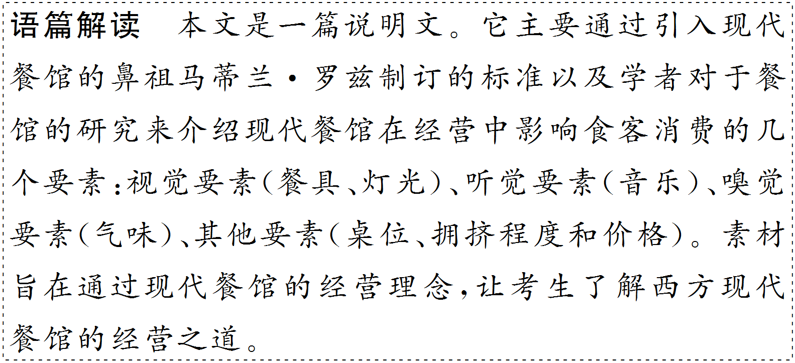
58．The underlined phrase “none the wiser” in Paragraph 3 most probably implies that the customers were .
A．not aware of eating more than usual
B．not willing to share food with others
C．not conscious of the food quality
D．not fond of the food provided
答案 A
解析 词义猜测题。根据第三段中的“...those given extralarge shares ate more than everyone else，but were none the wiser—they didn’t feel fuller...”可知，那些被给以大份饭菜的食客比其他人吃得多，但他们没觉得更饱，这说明在黑暗的就餐环境下，食客并不清楚自己多吃了多少，所以此处的none the wiser是“不清楚，不知道”之意。故选A项。
59．How could a fine dining shop make more profit?
A．Playing classical music.
B．Introducing lemon scent.
C．Making the light brighter.
D．Using plates of larger size.
答案 A
解析 细节理解题。根据第四段中的“When classical，rather than pop，music was playing，diners spent more.”可知，当演奏古典音乐而不是流行音乐的时候，食客们会花更多的钱。spent more就是对题干中make more profit的语意转化。故选A项。
60．What does the last paragraph talk about?
A．Tips to attract more customers.
B．Problems restaurants are faced with.
C．Ways to improve restaurants’ reputation.
D．Common misunderstandings about restaurants.
答案 D
解析 段落大意题。根据最后一段首句中的“things that you might expect to discourage spending—‘bad’tables，crowding，high prices—don’t necessarily”可知，你可能认为会打消你消费的念头的东西——位置“不好”的桌位、拥挤和价格高——未必如此(指在某些人看来，这些不利因素未必不会带来利润的增加)。由此可知，作者认为这些对于餐馆的常见的观点是一种误解，故选D项。
C
If you want to disturb the car industry，you’d better have a few billion dollars：Momandpop carmakers are unlikely to beat the biggest car companies.But in agriculture，small farmers can get the best of the major players.By connecting directly with customers，and by responding quickly to changes in the markets as well as in the ecosystems(生态系统)，small farmers can keep one step ahead of the big guys.As the cofounder of the National Young Farmers Coalition (NYFC，美国青年农会) and a family farmer myself，I have a frontrow seat to the innovations among small farmers that are transforming the industry.
For example，take the Quick Cut Greens Harvester，a tool developed just a couple of years ago by a young farmer，Jonathan Dysinger，in Tennessee，with a small loan from a local Slow Money group.It enables smallscale farmers to harvest 175 pounds of green vegetables per hour—a huge improvement over harvesting just a few dozen pounds by hand—suddenly making it possible for the little guys to compete with large farms of California.Before the tool came out，small farmers couldn’t touch the price per pound offered by California farms.But now，with the combination of a better price point and a generally fresher product，they can stay in business.
The sustainable success of small farmers，though，won’t happen without fundamental changes to the industry.One crucial factor is secure access to land.Competition from investors，developers，and established large farmers makes owning one’s own land unattainable for many new farmers.From 2004 to 2013，agricultural land values doubled，and they continue to rise in many regions.
Another challenge for more than a million of the most qualified farm workers and managers is a nonexistent path to citizenship—the greatest barrier to building a farm of their own.With farmers over the age of 65 outnumbering(多于) farmers younger than 35 by six to one，and with twothirds of the nation’s farmland in need of a new farmer，we must clear the path for talented people willing to grow the nation’s food.
There are solutions that could light a path toward a more sustainable and fair farm economy，but farmers can’t clumsily put them together before us.We at the NYFC need broad support as we urge Congress to increase farmland conservation，as we push for immigration reform，and as we seek policies that will ensure the success of a diverse and ambitious next generation of farmers from all backgrounds.With a new farm bill to be debated in Congress，consumers must take a stand with young farmers.

61．The author mentions car industry at the beginning of the passage to introduce .
A．the progress made in car industry
B．a special feature of agriculture
C．a trend of development in agriculture
D．the importance of investing in car industry
答案 B
解析 推理判断题。文章开头首先提到汽车行业的特点，“如果想进军汽车行业，你最好有几十亿美元：家庭经营的汽车制造厂不大可能击败最大的汽车公司”；接着指出“但是在农业方面，小农场主可以胜过大农场主”。由此可知，作者开头提到汽车行业是为了通过对比介绍农业的一个特色。
62．What does the author want to illustrate with the example in Paragraph 2?
A．Loans to small local farmers are necessary.
B．Technology is vital for agricultural development.
C．Competition between small and big farms is fierce.
D．Small farmers may gain some advantages over big ones.
答案 D
解析 细节理解题。根据第二段中的“...suddenly making it possible for the little guys to compete with large farms of California.”以及“...they can stay in business.”可知，Quick Cut Greens Harvester的发明让小农场可以与加利福尼亚的大农场竞争，并且可以继续经营下去，也就是说小农场主可能比大农场主获得了一些优势。
63．What is the difficulty for those new farmers?
A．To gain more financial aid.
B．To hire good farm managers.
C．To have farms of their own.
D．To win old farmers’ support.
答案 C
解析 细节理解题。根据第三段中的“Competition from investors，developers，and established large farmers makes owning one’s own land unattainable for many new farmers.”可知，来自投资者、开发商和资深的大农场主的竞争使许多新农场主无法拥有自己的土地，也就是说，新农场主面临的困难是“有自己的农场”。
64．What should farmers do for a more sustainable and fair farm economy?
A．Seek support beyond NYFC.
B．Expand farmland conservation.
C．Become members of NYFC.
D．Invest more to improve technology.
答案 A
解析 推理判断题。根据题干中的“a more sustainable and fair farm economy”定位到文章最后一段。该段提到NYFC在敦促国会增加耕地保护等方面需要支持，有关国会将要讨论的新农业法案，消费者必须与年轻农民站在一起。由此可知，为了使农场经济可持续和公平发展，农场主需要寻求NYFC以外的支持。
D
Children as young as ten are becoming dependent on social media for their sense of selfworth，a major study warned.
It found many youngsters(少年) now measure their status by how much public approval they get online，often through “likes”．Some change their behaviour in real life to improve their image on the web.
The report into youngsters aged from 8 to 12 was carried out by Children’s Commissioner(专员)Anne Longfield.She said social media firms were exposing children to major emotional risks，with some youngsters starting secondary school illequipped to cope with the tremendous pressure they faced online.
Some social apps were popular among the children even though they supposedly require users to be at least 13.The youngsters admitted planning trips around potential photoopportunities and then messaging friends—and friends of friends—to demand “likes” for their online posts.
The report found that youngsters felt their friendships could be at risk if they did not respond to social media posts quickly，and around the clock.
Children aged 8 to 10 were “starting to feel happy” when others liked their posts.However，those in the 10 to 12 age group were “concerned with how many people like their posts”，suggesting a “need” for social recognition that gets stronger the older they become.
Miss Longfield warned that a generation of children risked growing up “worried about their appearance and image as a result of the unrealistic lifestyles they follow on platforms，and increasingly anxious about switching off due to the constant demands of social media”．
She said：“Children are using social media with family and friends and to play games when they are in primary school.But what starts as fun usage of apps turns into tremendous pressure in real social media interaction at secondary school.”
As their world expanded，she said，children compared themselves to others online in a way that was “hugely damaging in terms of their selfidentity，in terms of their confidence，but also in terms of their ability to develop themselves”．
Miss Longfield added：“Then there is this push to connect—if you go offline，will you miss something，will you miss out，will you show that you don’t care about those people you are following，all of those come together in a huge way at once.”
“For children it is very，very difficult to cope with emotionally.” The Children’s Commissioner for England’s study—Life in Likes—found that children as young as 8 were using social media platforms largely for play.
However，the research—involving eight groups of 32 children aged 8 to 12—suggested that as they headed toward their teens，they became increasingly anxious online.
By the time they started secondary school—at age 11—children were already far more aware of their image online and felt under huge pressure to ensure their posts were popular，the report found.
However，they still did not know how to cope with meanspirited jokes，or the sense of incompetence they might feel if they compared themselves to celebrities(名人) or more brilliant friends online.The report said they also faced pressure to respond to messages at all hours of the day—especially at secondary school when more youngsters have mobile phones.
The Children’s Commissioner said schools and parents must now do more to prepare children for the emotional minefield(雷区) they faced online.And she said social media companies must also “take more responsibility”．They should either monitor their websites better so that children do not sign up too early，or they should adjust their websites to the needs of younger users.
Javed Khan，of children’s charity Barnardo’s，said：“It’s vital that new compulsory ageappropriate relationship and sex education lessons in England should help equip children to deal with the growing demands of social media.
“It’s also hugely important for parents to know which apps their children are using.”

65．Why did some secondary school students feel too much pressure?
A．They were not provided with adequate equipment.
B．They were not well prepared for emotional risks.
C．They were required to give quick responses.
D．They were prevented from using mobile phones.
答案 B
解析 细节理解题。根据第三段中的“She said social media firms were exposing children to major emotional risks，with some youngsters starting secondary school illequipped to cope with the tremendous pressure they faced online.”可知，一些中学生承受着感情方面的巨大压力，这是因为他们还没有做好如何处理在网上面临的极大压力的准备。B项中的“were not well prepared for”与原文中的“illequipped to cope with”表达的意思一致。
66．Some social app companies were to blame because .
A．they didn’t adequately check their users’ registration
B．they organized photo trips to attract more youngsters
C．they encouraged youngsters to post more photos
D．they didn’t stop youngsters from staying up late
答案 A
解析 推理判断题。由第四段中的“Some social apps were popular among the children even though they supposedly require users to be at least 13.”可知，一些社交app本应该只允许13岁及13岁以上的人使用。第六段提到，8～12岁的孩子也喜欢自己的帖子在社交app上受到别人的关注，这不利于他们的成长，因此，这些开发社交app的公司应该为对用户的注册信息审核不够严格而负责任，故选A项。
67．Children’s comparing themselves to others online may lead to .
A．less friendliness to each other
B．lower selfidentity and confidence
C．an increase in online cheating
D．a stronger desire to stay online
答案 B
解析 细节理解题。由题干中的“comparing themselves to others online”定位到原文第九段。由“...children compared themselves to others online in a way that was ‘hugely damaging in terms of their selfidentity，in terms of their confidence，but also in terms of their ability to develop themselves’．”可知，如果孩子们在网上把他们自己与别人作比较，这在某种程度上可能会极大地损害他们的自我认同感、自信以及发展自我的能力。故选B项。
68．According to Life in Likes，as children grew，they became more anxious to .
A．circulate their posts quickly
B．know the qualities of their posts
C．use mobile phones for play
D．get more public approval
答案 D
解析 推理判断题。由文章倒数第七段中的“...found that children as young as 8 were using social media platforms largely for play.”及倒数第五段“By the time they started secondary school—at age 11—children were already far more aware of their image online and felt under huge pressure to ensure their posts were popular，the report found.”可知，报道发现，那些8岁的喜欢使用媒体平台的孩子11岁时更加注重自己的网络形象，常常为了保证自己的帖子受欢迎而处于极大的压力之下，这说明他们更加渴望得到公众的认可，故选D项。
69．What should parents do to solve the problem?
A．Communicate more with secondary schools.
B．Urge media companies to create safer apps.
C．Keep track of children’s use of social media.
D．Forbid their children from visiting the web.
答案 C
解析 细节理解题。由文章的最后一段“It’s also hugely important for parents to know which apps their children are using.”可知，作为家长，知道自己的孩子正在使用哪些app也很重要，这与C项的表述一致，故选C项。keep track of了解……的动态；与……保持联系。
70．What does the passage mainly talk about?
A．The influence of social media on children.
B．The importance of social media to children.
C．The problem in building a healthy relationship.
D．The measure to reduce risks from social media.
答案 A
解析 主旨大意题。这篇新闻报道的首句指出，一项重要的研究警告说，10岁的孩子正变得依靠网络来获得自我价值感。接下来文章详细报道了一些社交app对孩子的影响。因为孩子还没有网络辨识能力，所以一旦养成在网络上与别人作比较的习惯，就很容易缺乏自我认同感、自信和发展自我的能力。因此A项“社交媒体对孩子的影响”是全文的主旨。
第四部分：任务型阅读(共10小题；每小题1分，满分10分)
请认真阅读下面短文，并根据所读内容在文章后表格中的空格里填入一个最恰当的单词。
注意：请将答案写在答题卡上相应题号的横线上。每个空格只填一个单词。
How Arts Promote Our Economy
When most people think of the arts，they imagine the end product，the beautiful painting，a wonderful piece of music，or an awardwinning performance in the theater.But arts groups bring broader value to our communities.The economic impact of the arts is often overlooked and badly judged.
The arts create jobs that help develop the economy.Any given performance takes a tour bus full of artists，technical experts，managers，musicians，or writers to create an appealing piece of art.These people earn a living wage for their professional knowledge and skills.
Another group of folks is needed to help market the event.“If you build it they will come” is a misleading belief.Painters，digital media experts，photographers，booking agents and promoters are hired to sell tickets and promote the event.According to the Dallas Area Cultural Advocacy Coalition，arts agencies employ more than 10,000 people as full or parttime employees or independent contractors.
A successful arts neighborhood creates a ripple effect(连锁反应) throughout a community.In 2005，when the Bishop Arts Theatre was donated to our town，the location was considered a poor area of town.After investing more than INCLUDEPICTURE "\\\\张潇\\f\\幻灯片原文件\\2018\\同步\\英语\\2018英语高考题\\美元.TIF" \* MERGEFORMATINET INCLUDEPICTURE "\\\\张潇\\f\\幻灯片原文件\\2018\\同步\\英语\\2018英语高考题\\美元.TIF" \* MERGEFORMATINET INCLUDEPICTURE "\\\\张潇\\f\\幻灯片原文件\\2018\\同步\\英语\\2018英语高考题\\美元.TIF" \* MERGEFORMATINET 1 million in reconstructing the building，we began producing a full season of theater performances，jazz concerts，and yearround arts education programs in 2008.Nearly 40 percent of jazz lovers live outside of the Dallas city limits and drive or fly in to enjoy an evening in the Bishop Arts District.
No doubt the theater has contributed to the area’s development and economic growth.Today，there are galleries，studios，restaurants and newly built work spaces where neighbors share experiences，where there is renewed life and energy.In this way，arts and culture also serve as a public good.
TeCo Theatrical Productions Inc.made use of Bloomberg’s investment of INCLUDEPICTURE "\\\\张潇\\f\\幻灯片原文件\\2018\\同步\\英语\\2018英语高考题\\美元.TIF" \* MERGEFORMATINET INCLUDEPICTURE "\\\\张潇\\f\\幻灯片原文件\\2018\\同步\\英语\\2018英语高考题\\美元.TIF" \* MERGEFORMATINET INCLUDEPICTURE "\\\\张潇\\f\\幻灯片原文件\\2018\\同步\\英语\\2018英语高考题\\美元.TIF" \* MERGEFORMATINET 35,000 to get nearly INCLUDEPICTURE "\\\\张潇\\f\\幻灯片原文件\\2018\\同步\\英语\\2018英语高考题\\美元.TIF" \* MERGEFORMATINET INCLUDEPICTURE "\\\\张潇\\f\\幻灯片原文件\\2018\\同步\\英语\\2018英语高考题\\美元.TIF" \* MERGEFORMATINET INCLUDEPICTURE "\\\\张潇\\f\\幻灯片原文件\\2018\\同步\\英语\\2018英语高考题\\美元.TIF" \* MERGEFORMATINET 400,000 in public and private sector support during the twoyear period.Further，Dallas arts and artsbased businesses produce INCLUDEPICTURE "\\\\张潇\\f\\幻灯片原文件\\2018\\同步\\英语\\2018英语高考题\\美元.TIF" \* MERGEFORMATINET INCLUDEPICTURE "\\\\张潇\\f\\幻灯片原文件\\2018\\同步\\英语\\2018英语高考题\\美元.TIF" \* MERGEFORMATINET INCLUDEPICTURE "\\\\张潇\\f\\幻灯片原文件\\2018\\同步\\英语\\2018英语高考题\\美元.TIF" \* MERGEFORMATINET 298 for every dollar the city spends on arts programming and facilities.In Philadelphia，a metro area smaller than Dallas，the arts have an economic impact of almost INCLUDEPICTURE "\\\\张潇\\f\\幻灯片原文件\\2018\\同步\\英语\\2018英语高考题\\美元.TIF" \* MERGEFORMATINET INCLUDEPICTURE "\\\\张潇\\f\\幻灯片原文件\\2018\\同步\\英语\\2018英语高考题\\美元.TIF" \* MERGEFORMATINET INCLUDEPICTURE "\\\\张潇\\f\\幻灯片原文件\\2018\\同步\\英语\\2018英语高考题\\美元.TIF" \* MERGEFORMATINET 3 billion and support 44,000 jobs,80 percent of which actually lie outside the arts industry，including accountants，marketers，construction workers，hotel managers，printers，and other kinds of art workers.
The arts are efficient economic drivers and when they are supported，the entire smallbusiness community benefits.
It is wrong to assume arts groups cannot make a profit.But in order to stay in business，arts groups must produce returns.If you are a student studying the arts，chances are you have been illadvised to have a plan B．But those who truly understand the economic impact and can work to change the patterns can create a wide range of career possibilities.
Arts as an economic driver | Our communities 71.benefit from arts in terms of economy.
72.Ways/Aspects of arts’ promoting our economy | Arts activity demands a(n) 73.joint/collective effort.It involves creation，performance，and 74.promotion/marketing.  ★Artists make a living through their creative work.  ★Others get paid by marketing the event.
72.Ways/Aspects of arts’ promoting our economy | Arts have a gradually spreading 75.effect.They could help promote other industries whether they lie inside or outside arts.  ★Besides tickets，some jazz lovers will pay their 76.fares to and from the events.  ★Arts contribute to cultural development when people gather together to share their experience and renew their energy.
72.Ways/Aspects of arts’ promoting our economy | Investment in arts could produce potential 77.positive economic results.  ★TeCo used a INCLUDEPICTURE "\\\\张潇\\f\\幻灯片原文件\\2018\\同步\\英语\\2018英语高考题\\美元.TIF" \* MERGEFORMATINET INCLUDEPICTURE "\\\\张潇\\f\\幻灯片原文件\\2018\\同步\\英语\\2018英语高考题\\美元.TIF" \* MERGEFORMATINET INCLUDEPICTURE "\\\\张潇\\f\\幻灯片原文件\\2018\\同步\\英语\\2018英语高考题\\美元.TIF" \* MERGEFORMATINET 35,000 art investment to attract an overall support of INCLUDEPICTURE "\\\\张潇\\f\\幻灯片原文件\\2018\\同步\\英语\\2018英语高考题\\美元.TIF" \* MERGEFORMATINET INCLUDEPICTURE "\\\\张潇\\f\\幻灯片原文件\\2018\\同步\\英语\\2018英语高考题\\美元.TIF" \* MERGEFORMATINET INCLUDEPICTURE "\\\\张潇\\f\\幻灯片原文件\\2018\\同步\\英语\\2018英语高考题\\美元.TIF" \* MERGEFORMATINET 400,000.  ★In Dallas，one dollar invested in arts could harvest an extraordinary return of nearly INCLUDEPICTURE "\\\\张潇\\f\\幻灯片原文件\\2018\\同步\\英语\\2018英语高考题\\美元.TIF" \* MERGEFORMATINET INCLUDEPICTURE "\\\\张潇\\f\\幻灯片原文件\\2018\\同步\\英语\\2018英语高考题\\美元.TIF" \* MERGEFORMATINET INCLUDEPICTURE "\\\\张潇\\f\\幻灯片原文件\\2018\\同步\\英语\\2018英语高考题\\美元.TIF" \* MERGEFORMATINET 300.  ★In Philadelphia the arts have created about 35,000 job opportunities for workers 78.outside/beyond arts industry.
Art students making a good living | With these 79.statistics/data/analyses in mind，art students need not worry about their career and have a(n) 80.alternative plan.

71．答案 benefit
解析 根据第二段首句“The arts create jobs that help develop the economy.”可知艺术创造就业岗位，推动经济发展，也就是说从经济角度而言，社会能从艺术发展中受益(benefit)。
72．答案 Ways/Aspects
解析 纵观语篇内容可知，文章重点介绍艺术在哪些方面能推动经济发展，故填ways或aspects，意为“方面”，注意首字母大写。
73．答案 joint/collective
解析 根据第三段首句“Another group of folks is needed to help market the event.”可知，艺术活动需要很多人来运作，group of folks可同义替换为joint/collective effort。
74．答案 promotion/marketing
解析 根据第三段第三句“Painters，digital media experts，photographers，booking agents and promoters are hired to sell tickets and promote the event.”可知，艺术活动涵盖了创作、表演和营销。promoters，promote可词形转换为promotion。故填promotion/marketing。
75．答案 effect
解析 根据第四段首句“A successful arts neighborhood creates a ripple effect(连锁反应) throughout a community.”和第五段首句“No doubt the theater has contributed to the area’s development and economic growth.”(毫无疑问，剧场有利于本地区的发展和经济增长)可知艺术对经济发展有扩散效应。根据a ripple effect可得出答案。
76．答案 fares
解析 根据第四段末句“Nearly 40 percent of jazz lovers live outside of the Dallas city limits and drive or fly in to enjoy an evening in the Bishop Arts District.”可知很多爵士乐爱好者来看演出要花交通费，故填fares。
77．答案 positive
解析 根据第六段首句“TeCo Theatrical Productions Inc.made use of Bloomberg’s investment of INCLUDEPICTURE "\\\\张潇\\f\\幻灯片原文件\\2018\\同步\\英语\\2018英语高考题\\美元.TIF" \* MERGEFORMATINET INCLUDEPICTURE "\\\\张潇\\f\\幻灯片原文件\\2018\\同步\\英语\\2018英语高考题\\美元.TIF" \* MERGEFORMATINET INCLUDEPICTURE "\\\\张潇\\f\\幻灯片原文件\\2018\\同步\\英语\\2018英语高考题\\美元.TIF" \* MERGEFORMATINET 35,000 to get nearly INCLUDEPICTURE "\\\\张潇\\f\\幻灯片原文件\\2018\\同步\\英语\\2018英语高考题\\美元.TIF" \* MERGEFORMATINET INCLUDEPICTURE "\\\\张潇\\f\\幻灯片原文件\\2018\\同步\\英语\\2018英语高考题\\美元.TIF" \* MERGEFORMATINET INCLUDEPICTURE "\\\\张潇\\f\\幻灯片原文件\\2018\\同步\\英语\\2018英语高考题\\美元.TIF" \* MERGEFORMATINET 400,000 in public and private sector support during the twoyear period.”可知，在音乐方面的投资能产生潜在的积极的经济回报。public and private sector support(国营部门和私营企业的支持)可转化为positive。
78．答案 outside/beyond
解析 根据第六段末句“...80 percent of which actually lie outside the arts industry，including accountants，marketers，construction workers，hotel managers...”可知，艺术为不从事这个行业的人也提供了就业机会。故填outside/beyond。
79．答案 statistics/data/analyses
解析 根据上文提供的数据或分析，我们就会得出学艺术的学生不必担心就业问题的结论。故填statistics/data/analyses。
80．答案 alternative
解析 根据文章最后的“...you have been illadvised to have a plan B．But those who truly understand the economic impact and can work to change the patterns can create a wide range of career possibilities.”可知，学艺术的学生就业前景光明，选择的范围很大，不必做另外的计划。由关键词a wide range of career possibilities可知填alternative。
第五部分：书面表达(满分25 分)
81．请阅读下面文字，并按照要求用英语写一篇150词左右的文章。
INCLUDEPICTURE "\\\\张潇\\f\\幻灯片原文件\\2018\\同步\\英语\\2018英语高考题\\S1.TIF" \* MERGEFORMATINET INCLUDEPICTURE "\\\\张潇\\f\\幻灯片原文件\\2018\\同步\\英语\\2018英语高考题\\S1.TIF" \* MERGEFORMATINET INCLUDEPICTURE "\\\\张潇\\f\\幻灯片原文件\\2018\\同步\\英语\\2018英语高考题\\S1.TIF" \* MERGEFORMATINET 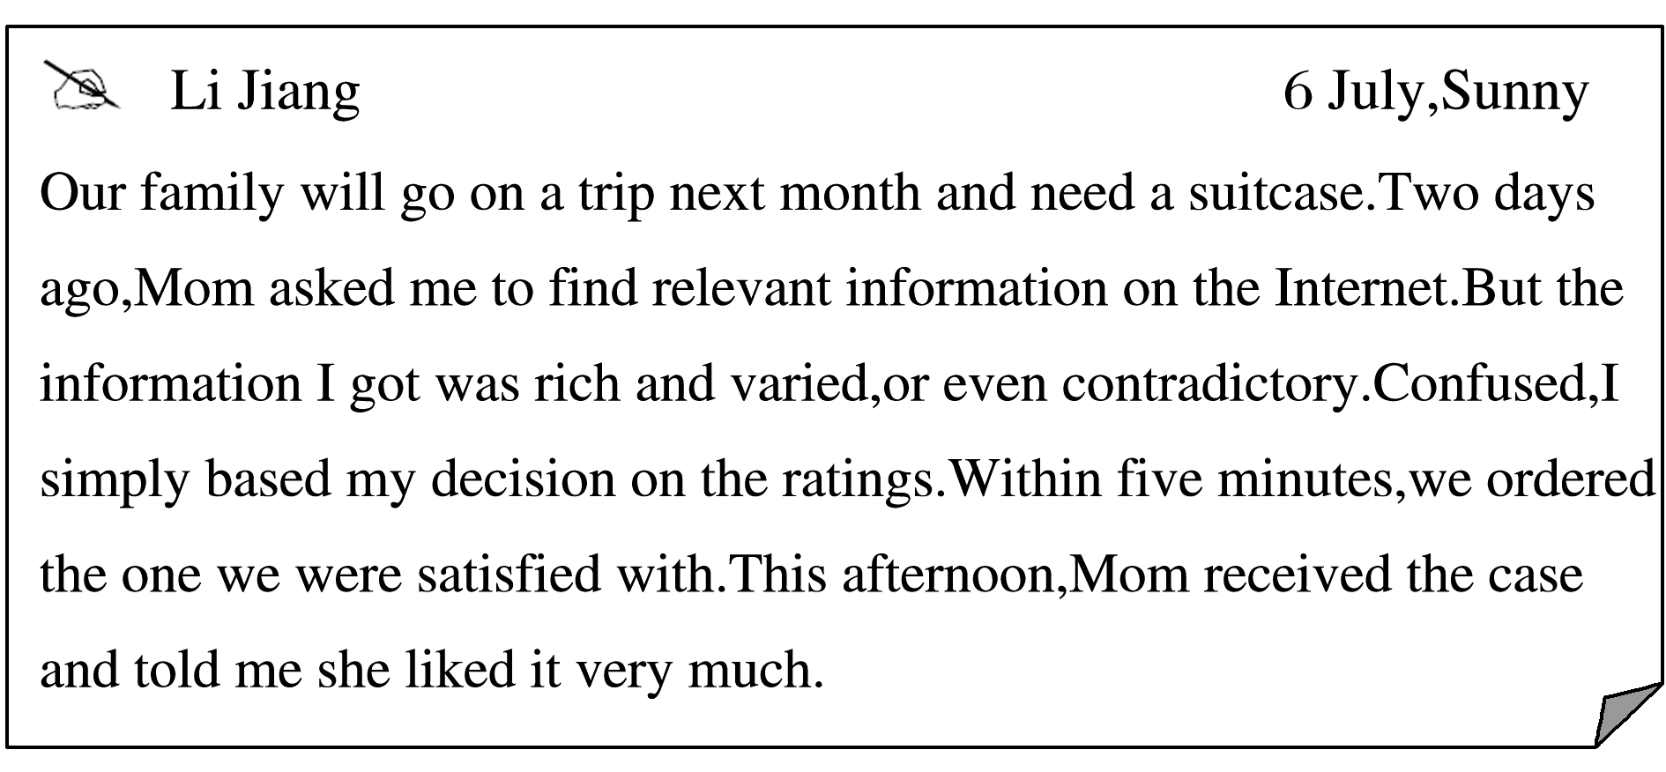
INCLUDEPICTURE "\\\\张潇\\f\\幻灯片原文件\\2018\\同步\\英语\\2018英语高考题\\S2.TIF" \* MERGEFORMATINET INCLUDEPICTURE "\\\\张潇\\f\\幻灯片原文件\\2018\\同步\\英语\\2018英语高考题\\S2.TIF" \* MERGEFORMATINET INCLUDEPICTURE "\\\\张潇\\f\\幻灯片原文件\\2018\\同步\\英语\\2018英语高考题\\S2.TIF" \* MERGEFORMATINET 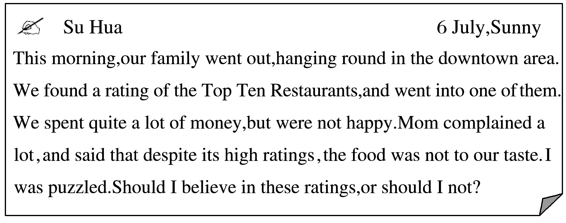
[写作内容]
1．用约30个词概括上述利用排名(ratings)进行消费的现象；
2．谈谈你如何看待消费排名，然后用2－3个理由或论据支撑你的看法。
[写作要求]
1．写作过程中不能直接引用原文语句；
2．作文中不能出现真实姓名和学校名称；
3．不必写标题。
[评分标准]
内容完整，语言规范，语篇连贯，词数适当。
[参考范文1]
As a major channel of consumption information，the rating is an efficient source of information for shopping in our own consumption.Interestingly，the same rating may have different influences on different consumers.
I tend to consult consumption ratings whatever I purchase.Firstly，the higher rating means the higher quality of the product，or better service.Based on the ratings，I bought my beloved backpack，saw interesting films and tasted delicious foods.Secondly，ratings can save time to make decisions in shopping.For example，there are huge numbers of reference books which I am often confused to choose from.In that case，it is both convenient and economical to buy books according to the ratings.
There is no doubt that it is unwise to depend completely on the ratings in consumption.The advantages and disadvantages of ratings are often closely related.It is necessary to hold an objective attitude towards ratings.
[参考范文2]
Nowadays，most commodities or services are rated through certain channels.These ratings，easy to access，are playing an increasingly important role in customers’ purchase decision.However，results are sometimes unsatisfactory.
There is no denying that such ratings might bring convenience to consumers，but they are often misleading and unreliable.As we all know，most of the ratings are based on others’ judgment on the product or service concerned.Every judgment comes from a specific need or a unique psychological state.Apparently，blindly following others’ advice will affect our own judgment.Another fact should not be neglected that some of the ratings are the outcome of a careful manipulation of companies or sellers.It has become a common practice for some to pay for good ratings on their products or services so as to increase their sales.
Therefore，we should give a second thought to these ratings whenever we go shopping.

